**A FULL STACK CAPSTONE**

**PROJECT**

***(FOOD BOX)***

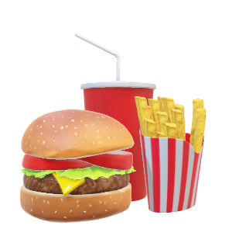

(Application Screenshot’s)

* **Version History:**

|  |  |  |
| --- | --- | --- |
| 1. | **Author Name** | Deepak Sharma |
| 2. | **Purpose** | Screenshots of Application. |
| 3. | **Date** | 20 December 2022. |
| 4. | **Version** | 1.0 |
| 5. | **Email id** | [*Deepak.rockstar29@gmail.com*](mailto:Deepak.rockstar29@gmail.com) |

1. **Project Outputs.**

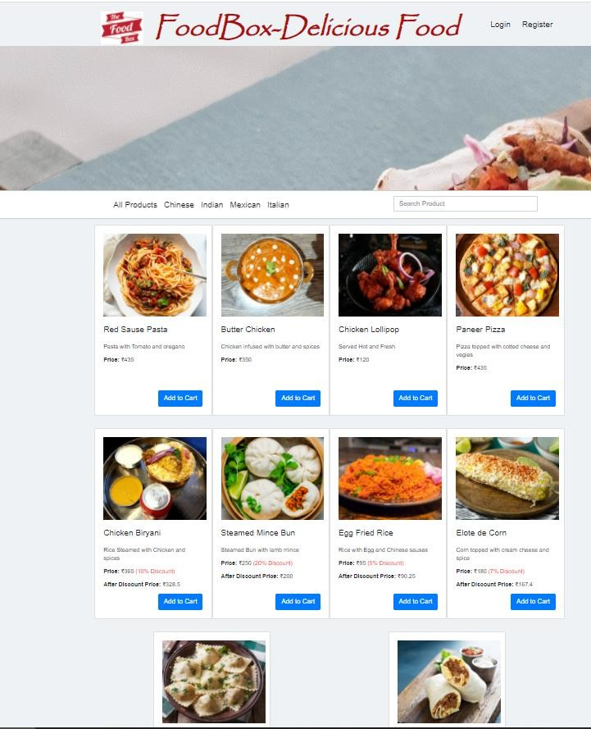

A. Home Page.

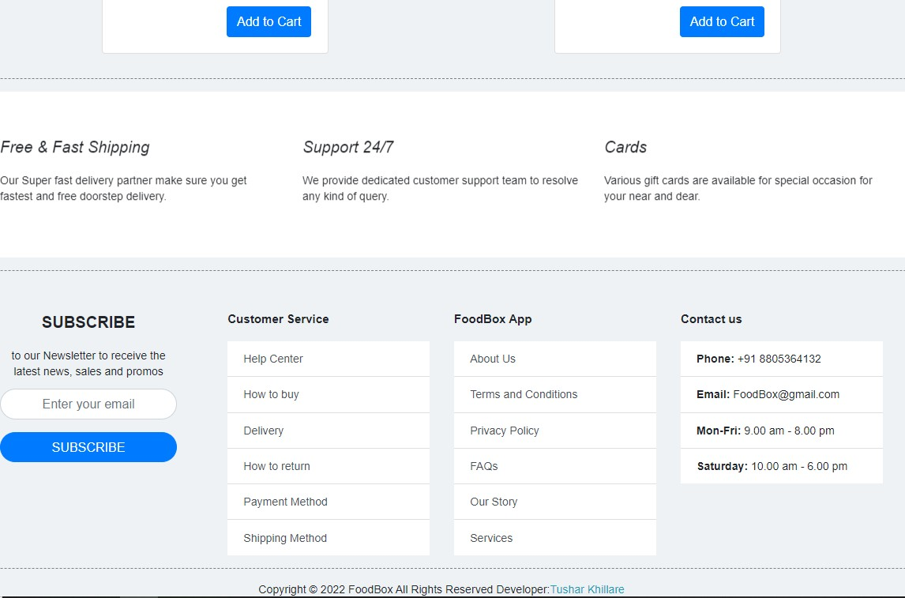

B. Login and Registration Page.

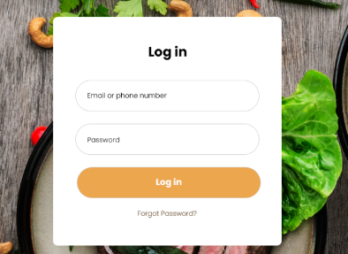



C. Admin Login Page.

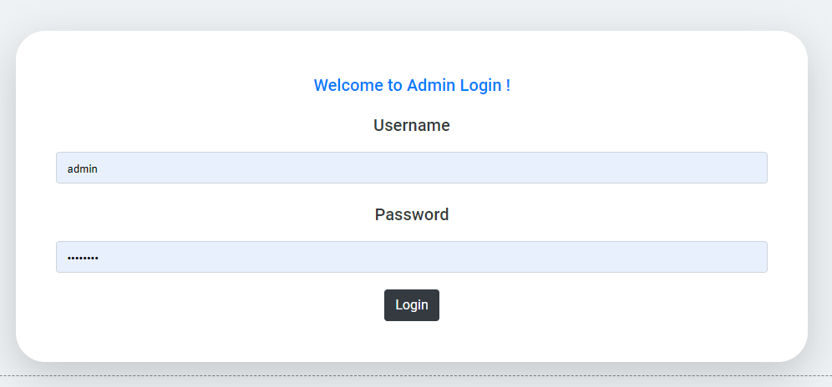

D. Manage Users , Products , Purchases.

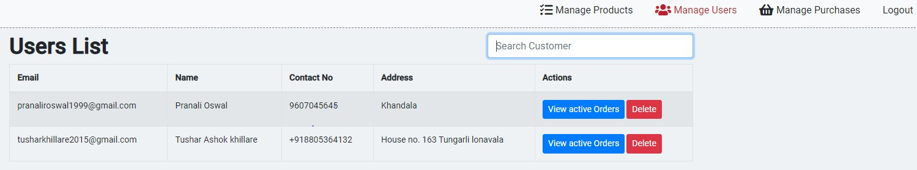

**Searching and Sorting:**

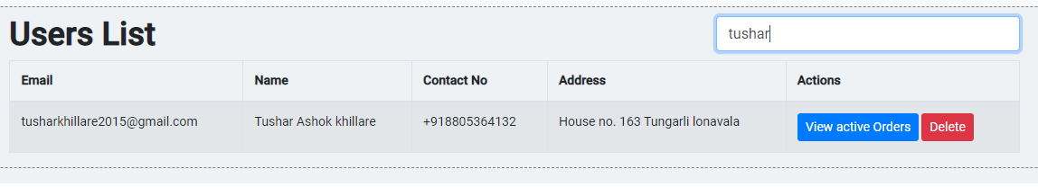

**Manage Products:**

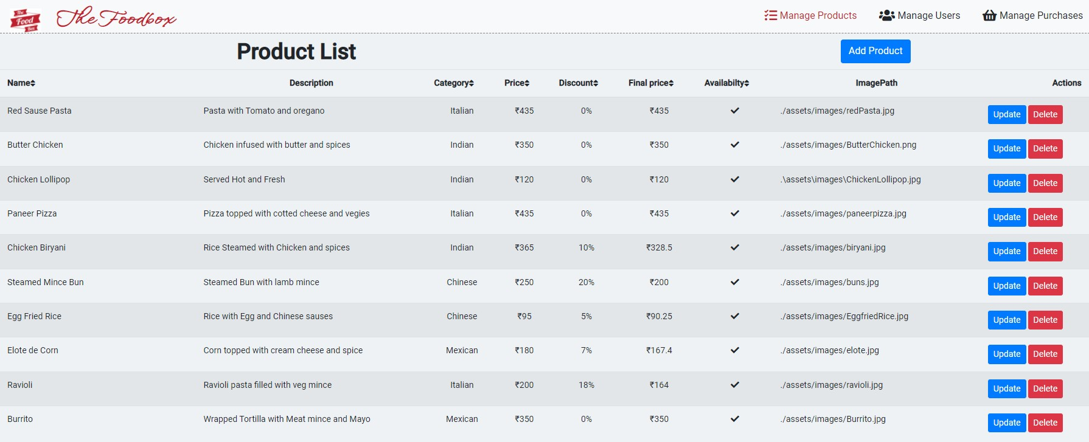

**Add Product:**

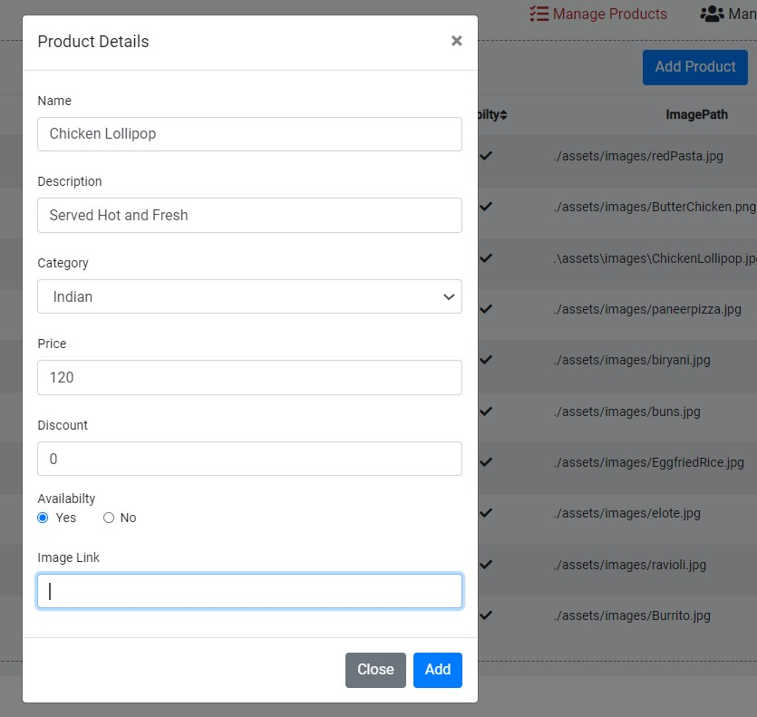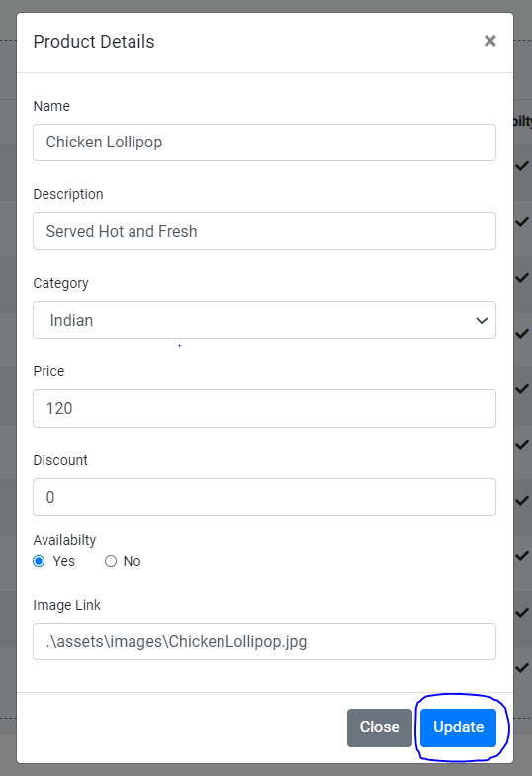

**Update Product:**

Delete Product:

Product deleted successfully…..

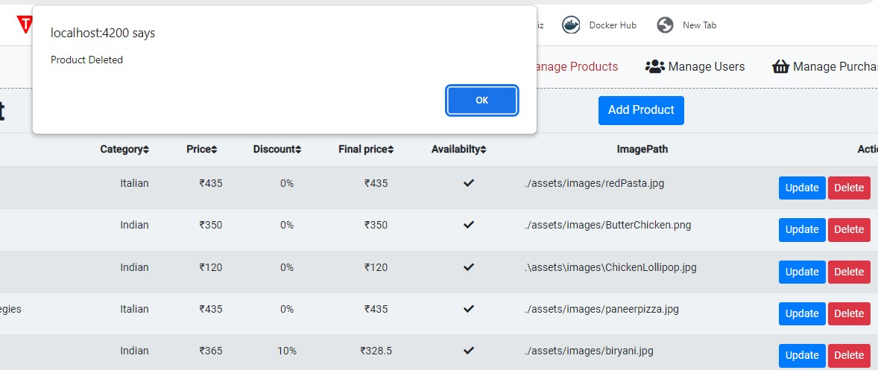

Manage Purchases:

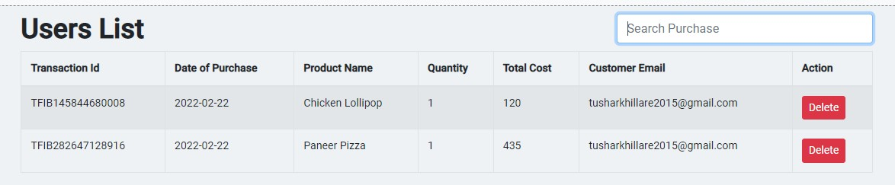





E. View Previous Active Orders.

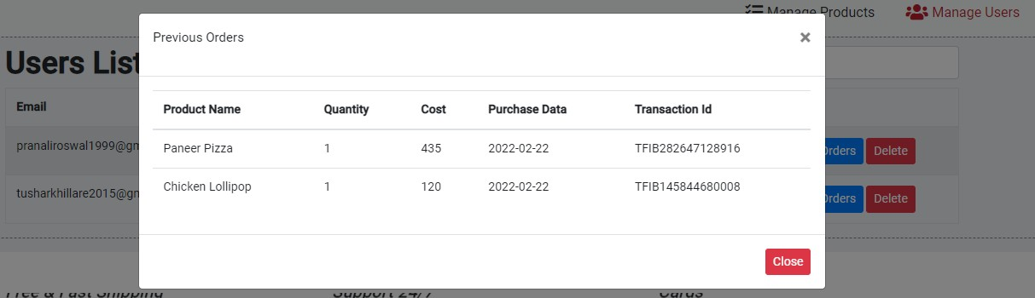

F. User Login.

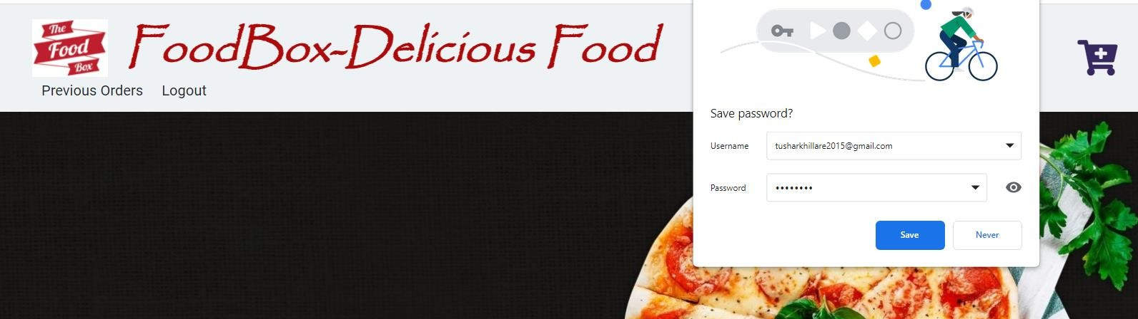

G. Add Cart / View Cart.

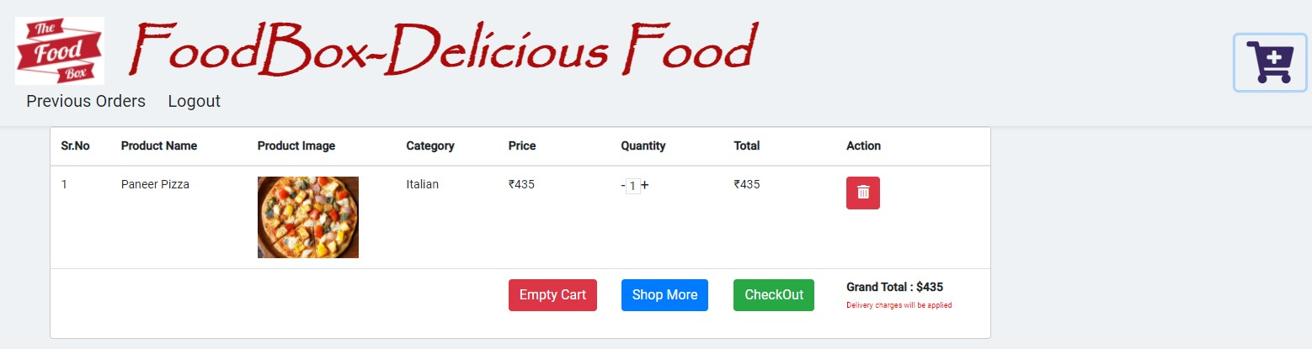

My Cart:

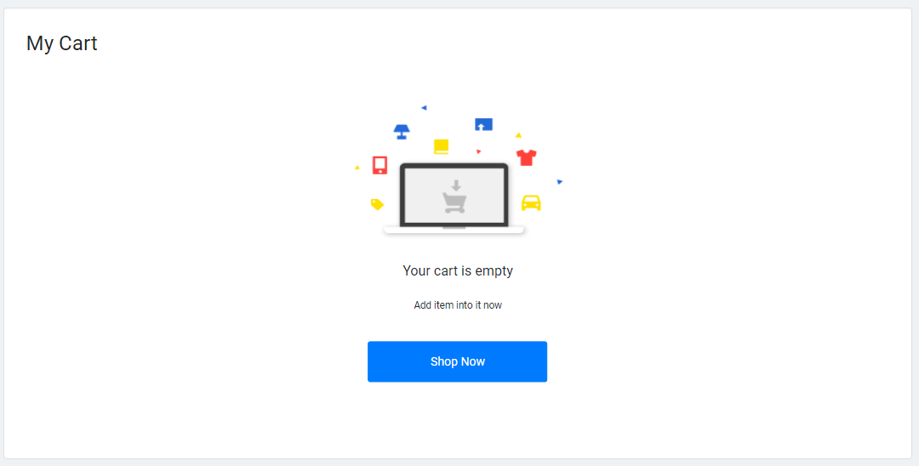

**PROJECT SCREENS POST TESTING AND JENKINS DEPLOYMENT**:

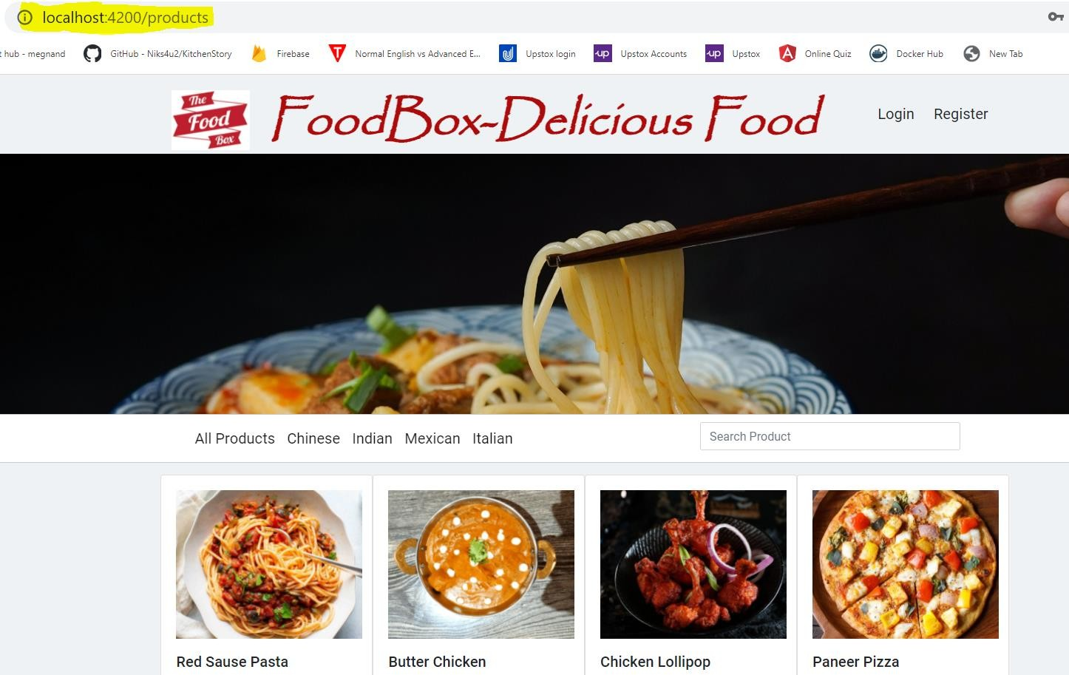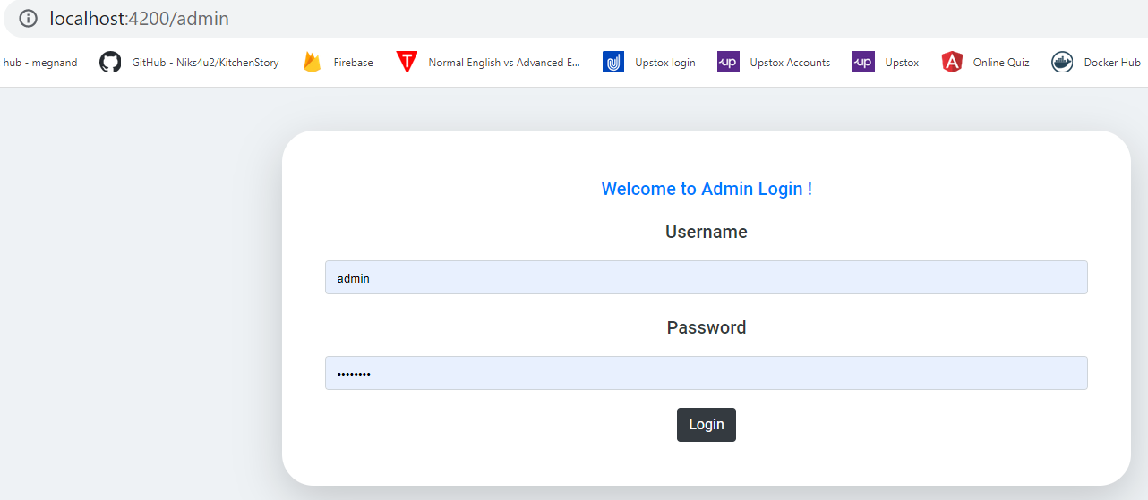

Category Based Searching

http://localhost:4200/products

15

*Thank you*